This guide is intended as a quick tutorial to use GAME MODE.
When you arrive in the scorebox, you will see one of three screens.
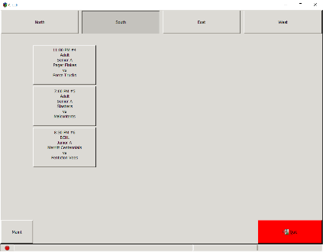 | 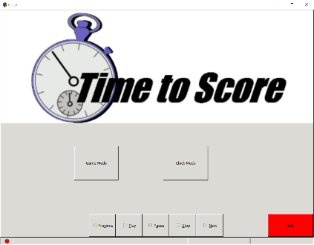 | 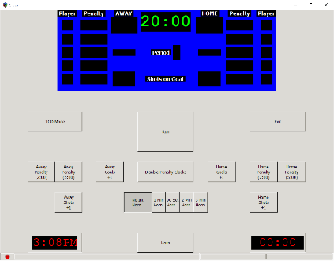
Game Mode Selector | Main Screen | Clock Mode

- If you see CLOCK MODE, touch the EXIT button.
- If you see the MAIN SCREEN, touch the GAME MODE BUTTON.
- If you see the GAME MODE SELECTOR screen, touch the game you are scoring.

On selecting your game, you will see the following screen:
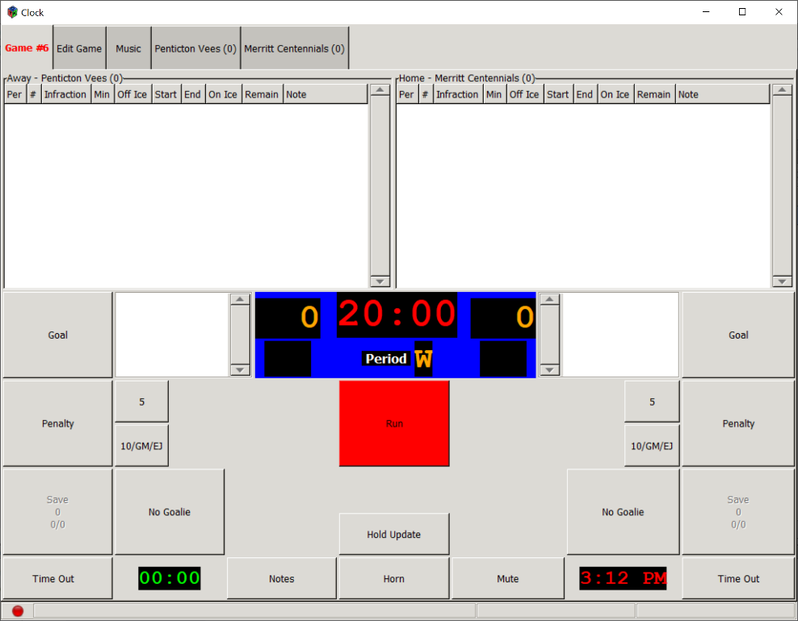
HELPFUL HINT: You can Start/Stop the clock while doing other tasks by pressing the Space Bar on your keyboard!

Getting the game started
At the top of the page you have five tabs: Game #, Edit Game, Music and the two teams playing.
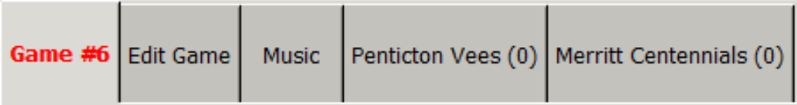
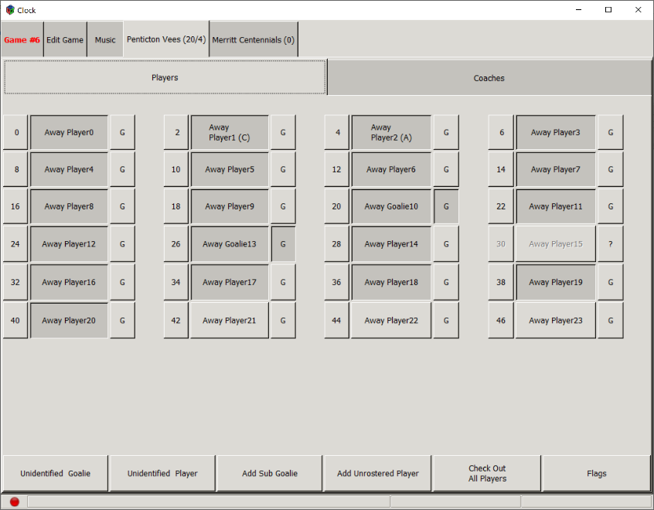
Select one of the team tabs to check in players.

Touch the player’s name to check in a player. Players with a darker button are checked in. Lighter button indicates the player is scratched (not playing). Only players on the roster should be checked in. The tab at the top will indicate the number of players (and coaches, if available) that are checked in.

- Match the player’s name – not the number.
- If the player’s number does not match the roster, touch the number next to that player’s name.
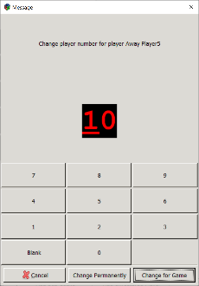
Enter the correct number and press CHANGE PERMANENTLY or CHANGE FOR GAME.
- Goalies are marked by the G button to the right of the player. Goalies must be indicated to assign that player as the goalie on the Main Screen. If a goalie isn’t checked into the game and assigned at the start, you will not be able to record Shots/Saves.
- If the player on your scoresheet is not listed on this screen, you can use the Add Unrostered Player and search by last name or simply use the Unidentified Player/Unidentified Goalie button and assign a jersey number to that player.
- You will not be permitted to enter more players over the permitted limit for your league.
- Repeat for the second team.

Assign Starting Goaltenders
After entering the rosters, go back to the GAME tab. Touch the Goalie button for each team to select the starting goalie.
- Push the button for the correct goalie.
- If the goalie is pulled at any time, select EMPTY NET.
- If you need to record saves/shots on a scoresheet after the game, you can use this screen to view those statistics and then hit CANCEL to go back to the Game tab.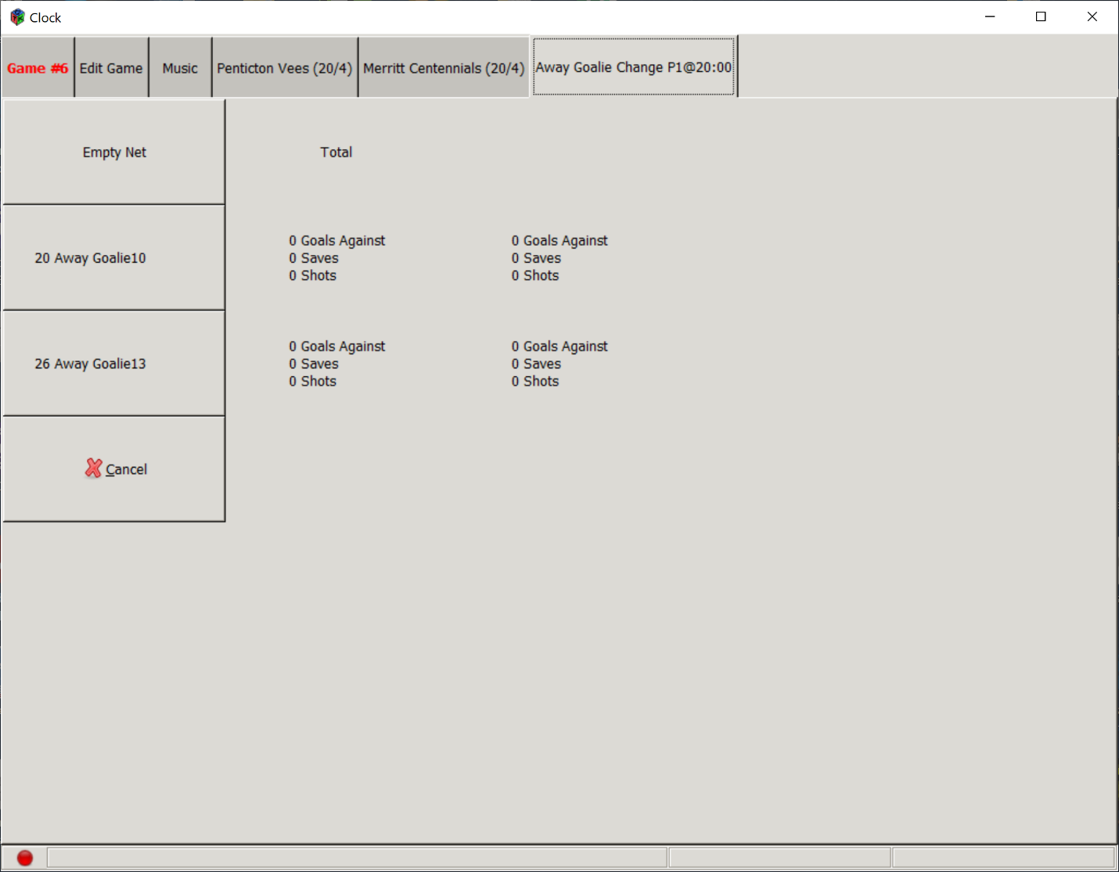

Scoring the Game
GOALS
- Clock must be stopped.
- Press GOAL for the appropriate team.
- Press the player who scored the goal
- Press the player credited with the first assist. If unassisted, press NONE or OK.
- PENALTY SHOT GOALS: If a goal is scored as the result of a penalty (such as a Penalty Shot or Awarded for Thrown Stick), use the procedure for PENALTIES.
PENALTIES
All penalties must be entered into the computer regardless of whether or not they will “go on the board”. If it would be written on a scoresheet, it must be recorded in the computer.
All offsetting penalties, game misconducts, disqualifications and ejections must be entered.
The scoreboard will only display penalties required by the rules for this game.
- Clock must be stopped.
- Press PENALTY for the appropriate team.
- Press the player who received the penalty. If the penalty is assigned to BENCH, push the BENCH button at the bottom of the roster. (For example: Too Many Men is a bench minor.)
Do not assign the penalty to the player serving the penalty. This player wasn’t assessed the penalty and is only serving the penalty. On a scoresheet you would write “B” or “Bench” to indicate the bench minor.
- Press the infraction. If the infraction is not on the first screen, use the tabs on the left side to find Serious or Uncommon infractions.
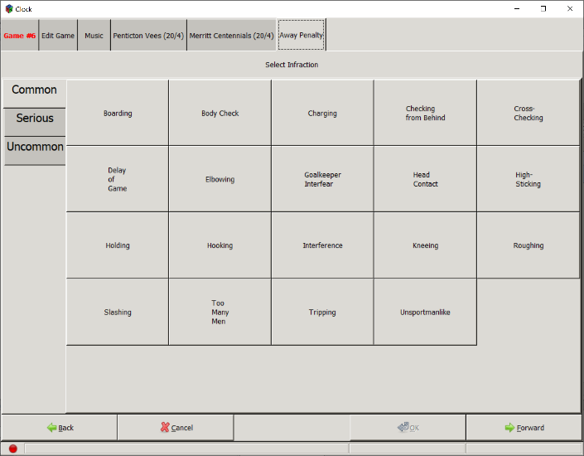
- Press the type of penalty (minor, double minor, major, etc.)
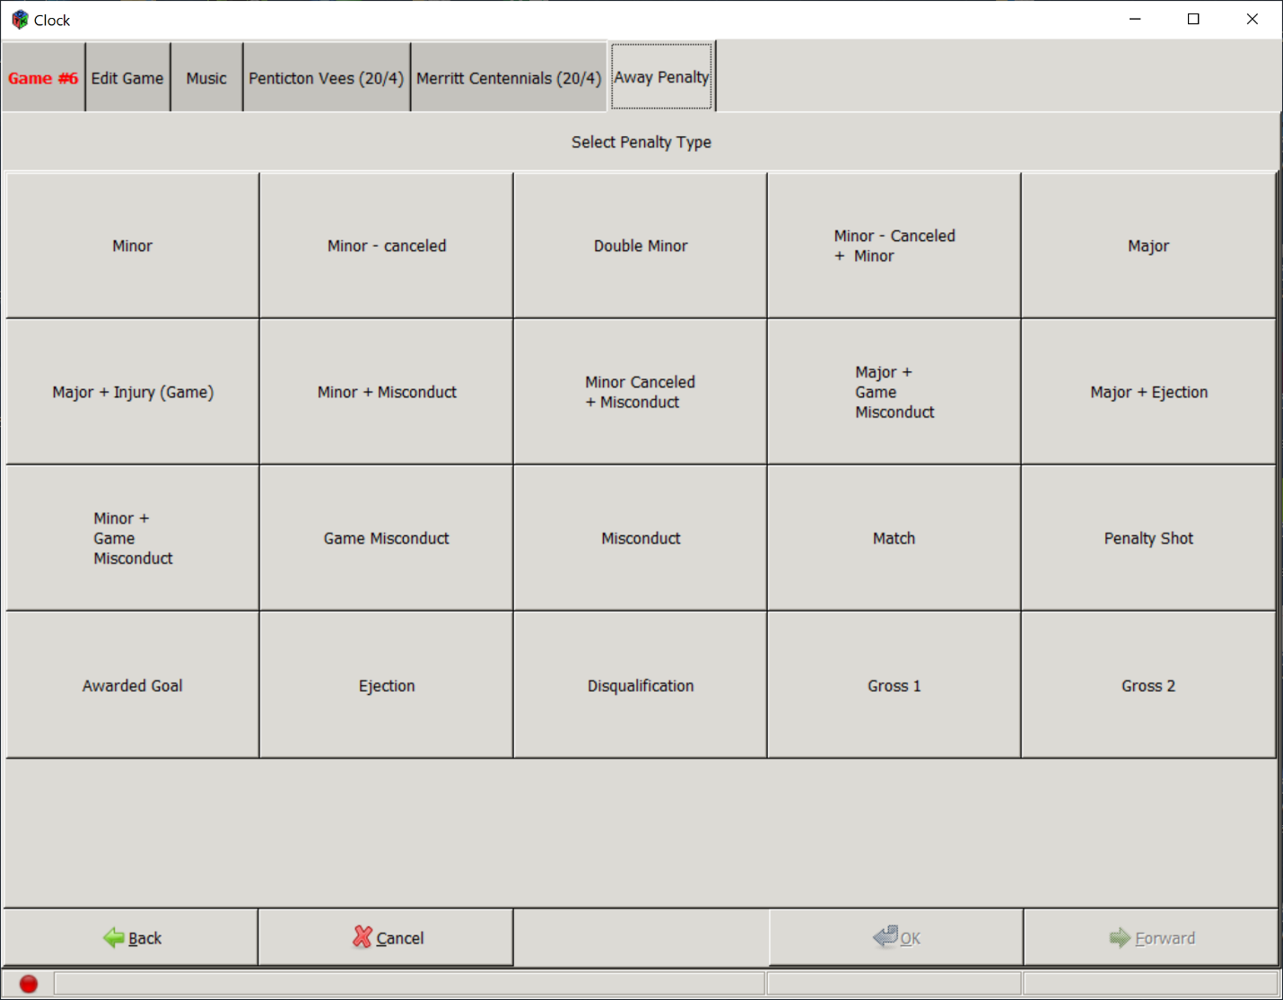
- Simultaneous penalties must be entered.
  - If your league has no change of strength due to offsetting penalties (stays 5 on 5, for example), you will see them listed as follows on your screen:
The “W” next to the time in the ON ICE column indicates that the players return to the ice after the penalties expire PLUS a WHISTLE. If the time expires and the play continues, you will see an indicator to remind you to wait for the whistle before the players are allowed out of the box.
The scoreboard will not display these penalties. Only when the screen shows RELEASE will the players be allowed out of the box.
  - If your league reduces strength (4 on 4, for example), the penalties will show on the scoreboard.
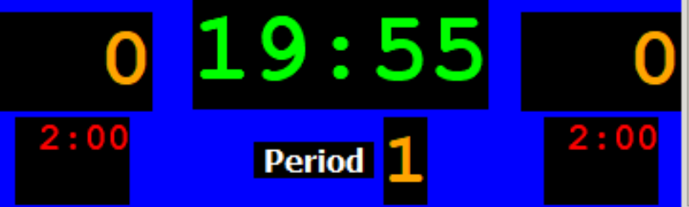
PENALTY SHOTS
If the penalty results in a Penalty Shot, begin by entering a penalty. On the Type screen, push PENALTY SHOT. This will automatically advance to Penalty Shot Info screen.
Press the player taking the Penalty Shot then SUCCEEDED or FAILED.
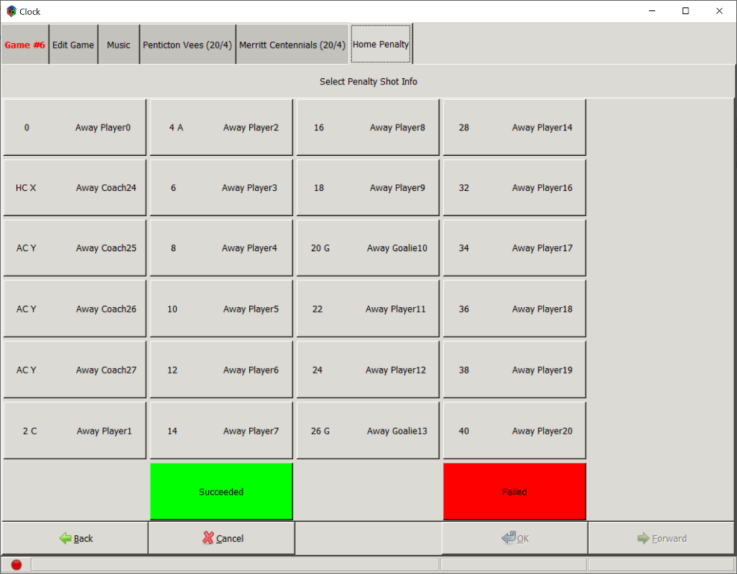

TIMEOUTS
All timeouts should be entered into the computer. The clock will run for the appropriate time based on your league. Enter the time on your scoresheet (if needed).

FIXING ERRORS
If you need to go back and correct errors to the game, use the EDIT GAME tab. This includes
- Changing/deleting goals/assists
- Inserting Goalies or Replacing Goalies
- Changing/deleting penalties
- Deleting Saves/Shots
- Forfeit
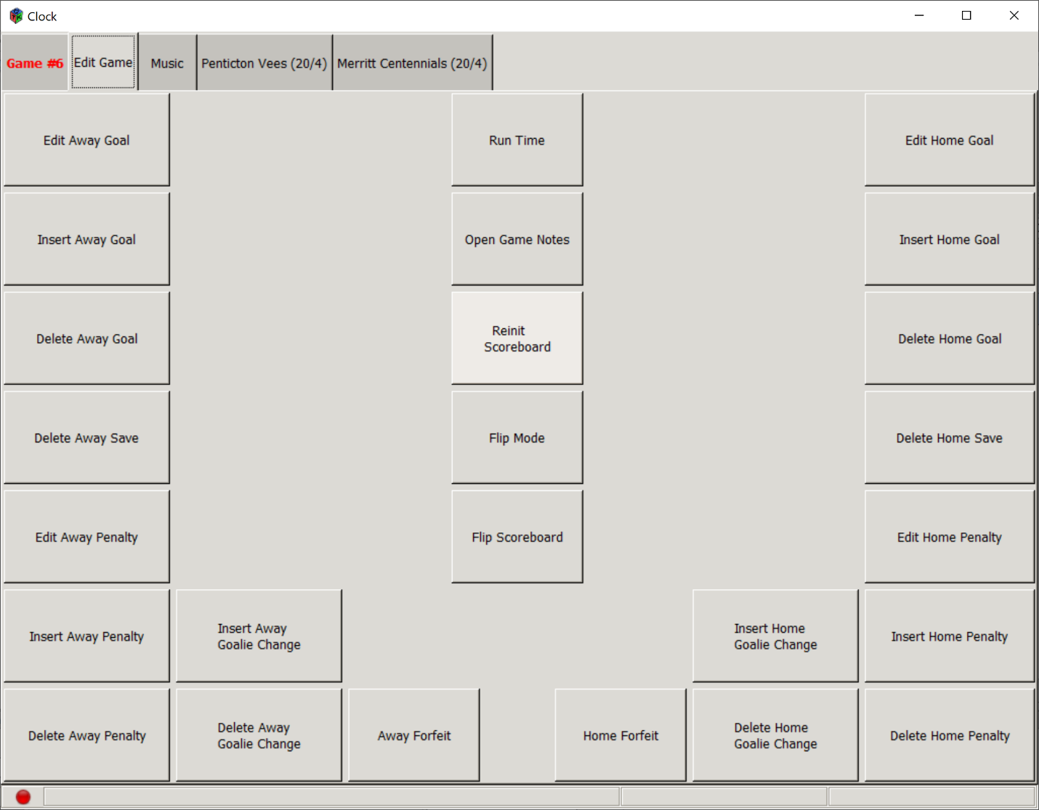

Ending the Game
If your game has Overtime or Shootouts, it will automatically appear. Overtime is run like the rest of the game.
SHOOTOUTS
If your league has shootouts, you will see this button.
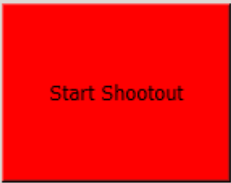
To start the shootout, push the button.
- If your league only wants to know who won, you will see a screen to indicate the winner.
- If your league allows for the captain to shoot first or second, you will select the appropriate choice.
- If your league decides who starts, the screen will indicate which team starts.
- The screen will present the roster of eligible shooters. Select the player attempting the shot and whether it succeeded or failed.
- The screen will alternate between HOME/AWAY rosters until the shootout is over.
- At the end of the shootout, press OK.
Upon completion of the game, simply push the yellow END GAME button. It will replace the Start/Stop button.
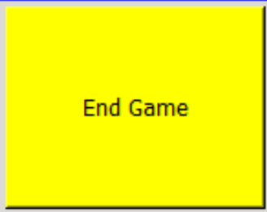
If you have any “Open Tabs” (plays that have not been fully entered), you will receive a warning:
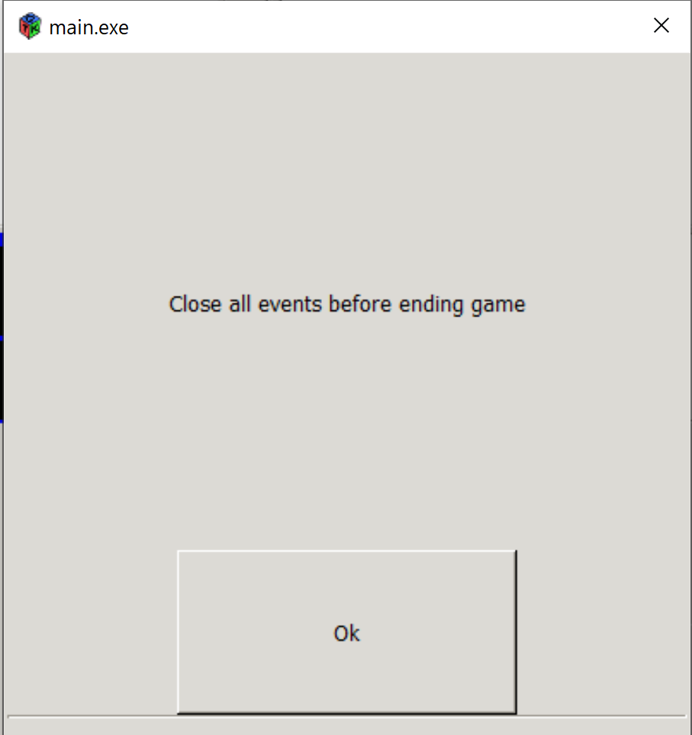
Press OK and look at the top of your screen for any penalties or goals that must be completely entered.

